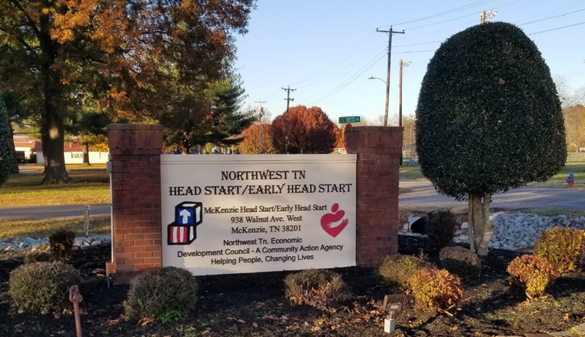

**Northwest Tennessee Economic Development Council**

**Head Start/Early Head Start**

**Annual Report**

**2023-2024**

MISSION:

Helping people, changing lives in our community through education, partnerships, and delivery of quality services in Northwest Tennessee**.**

VISION:

Hand in hand, working together we are dedicated to helping people help themselves and each other to make a difference in our communities.



Cheryl Oglesby Townes, Executive Director

Rakaya Humphreys, Head Start/Early Head Start Director

**Northwest Tennessee**

**Head Start/Early Head Start**

**938C Walnut Avenue W.**

**McKenzie, TN 38201**

**(731) 352 – 4743**

**(731) 352 – 8380 Fax**

**Annual Report**

**Annual report is prepared to comply with the Head Start Reauthorization Act of 2007, Administrative Requirements and Standards Sec. 644[42 U.S.C. 9839 (a)(2)]**

**Head Start Act, Amended 2007--------Sec. 644 (a)(2) (A-H)**

(2) Each Head Start agency shall make available to the public a report published at least once in each fiscal year that discloses the following information from the most recently concluded fiscal year, except that reporting such information shall not reveal personally identifiable information about an individual child or parent:

(A) The total amount of public and private funds received and the amount from each source.

(B) An explanation of budgetary expenditures and proposed budget for the fiscal year.

(C) The total number of children and families served, the average monthly enrollment (as a percentage of funded enrollment), and the percentage of eligible children served.

(D) The results of the most recent review by the Secretary and the financial audit.

(E) The percentage of enrolled children that received medical and dental exams.

(F) Information about parent involvement activities.

(G) The agency's efforts to prepare children for kindergarten.

(H) Any other information required by the Secretary.

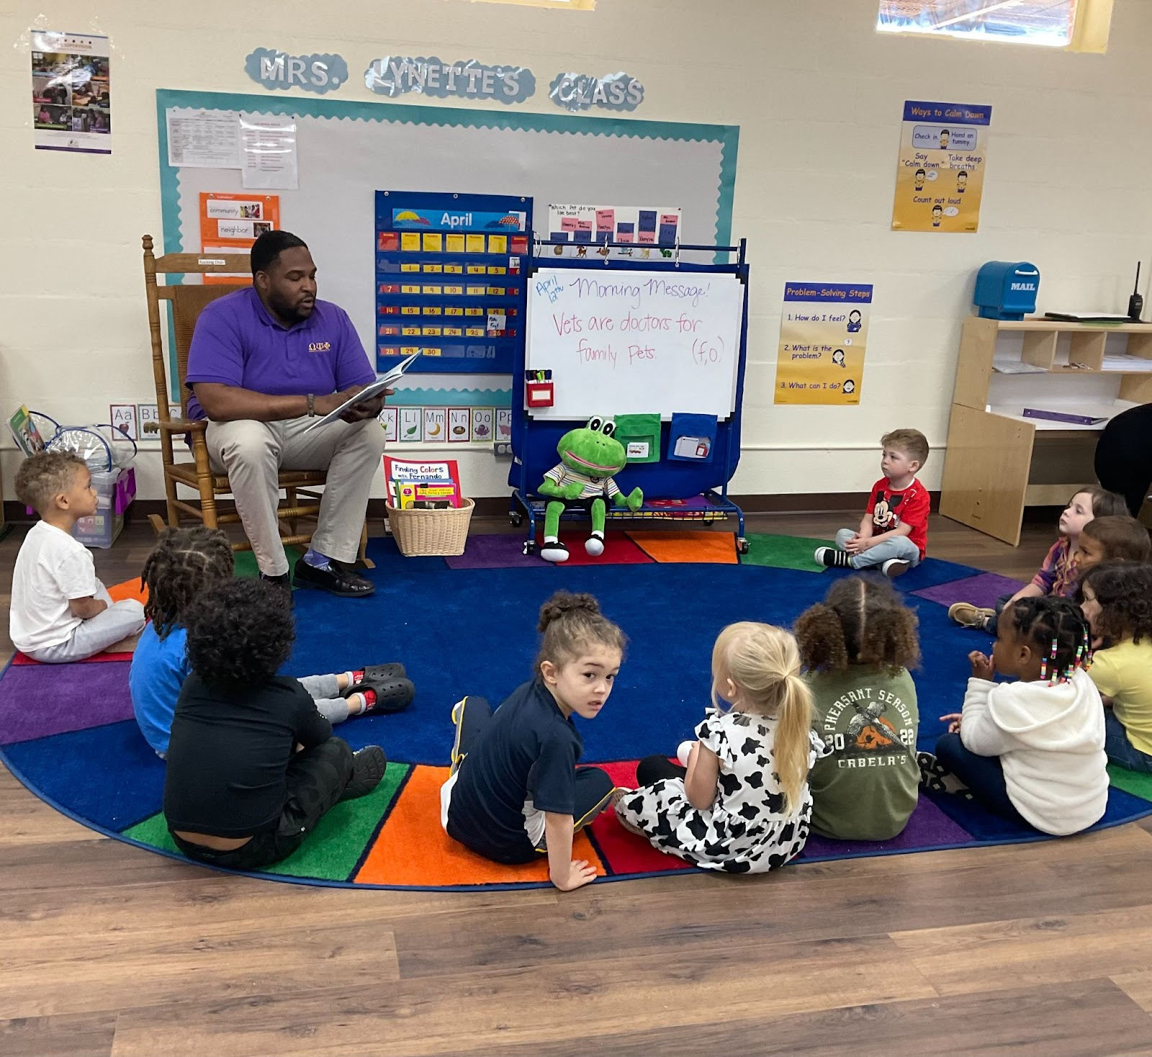

**Program Philosophy**

Our program philosophy is simple, “Invest now, benefit later.” We believe that high quality early childhood care, education and family services pay off in a myriad of benefits to children, their families and society. Children learn best when fully involved and self-directed in their learning. This child-centered philosophy supports our belief that children are unique individuals who learn at different rates and in diverse ways. It is our responsibility to allow each child the opportunity to gain experience and develop to his/her fullest potential in the most nurturing environment possible. In addition, we believe parents are an integral part of the child’s learning process. Both teachers and parents work together to plan and facilitate the educational goals for the child. Our goal is to bring about a greater degree of social competence in children of low-income families. Social competence relates to the child’s everyday effectiveness in dealing with both the present environment and later responsibilities in school and in life. It considers the interrelatedness of cognitive and intellectual development, physical and mental health and nutritional needs.

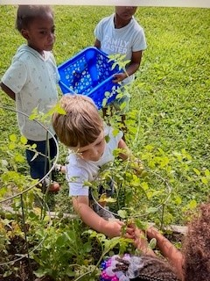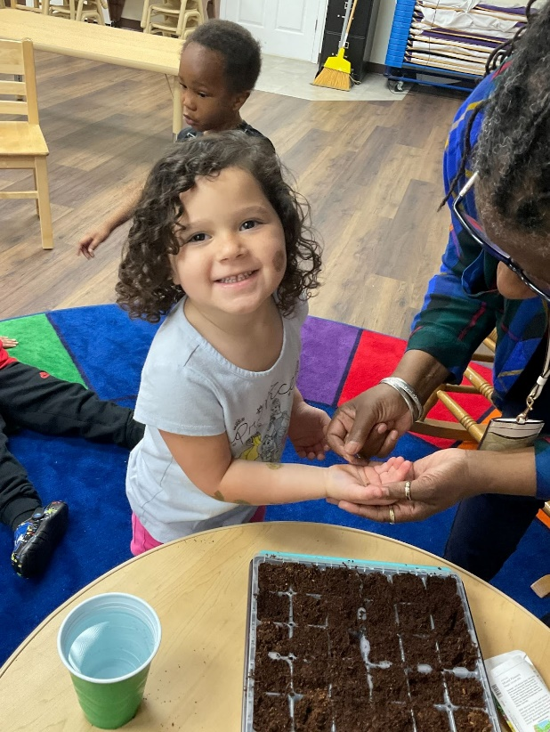

Northwest Tennessee Economic Development Council (NWTEDC) is a public non-profit community action agency. NWTEDC community service programs provide assistance to income-eligible households and individuals and serves as the grantee for the Northwest Tennessee Head Start/Early Head Start program.

The established service area for Northwest Tennessee Head Start/Early Head Start encompasses eight counties in Northwest and Southwest. Seven of the counties are classified as rural with one county being classified as urban.

These counties stretch from the Tennessee River on the east to the Mississippi River on the west and are bordered by Kentucky on the north, Arkansas and Missouri on the west, and Mississippi on the south. Seven of the counties, Benton, Carroll, Gibson, Henry, Lake, Obion, and Weakley lie in the Northwest Tennessee Development District while Madison County is in the Southwest District.

Services are currently funded for 739 Head Start and 132 Early Head Start children and families in 19 community-based centers. Head Start children served are enrolled for 160 days. Early Head Start services are available in five of the eight counties, while Head Start centers are in all eight counties. The program has entered into collaborative agreements with six local school systems at seven sites to provide services for 200 Head Start children in pre-kindergarten/Head Start classrooms for 180 days.

|  |  |  |
| --- | --- | --- |
| **County** | **Head Start** | **Early Head Start** |
| Benton County | 50 | 20 |
| Carroll County | 113 | 24 |
| Gibson County | 131 | 0 |
| Henry County | 104 | 0 |
| Lake County | 17 | 8 |
| Madison County | 191 | 56 |
| Obion County | 64 | 24 |
| Weakley County | 69 | 0 |
| **Funded Enrollment** | **739** | **132** |

**The average monthly enrollment as a percentage of funded enrollment is 100%.**

**Services include:**

* Preschool education and family support
* School readiness
* Preventive health care for each child
* Dental exams and follow-up
* Health insurance referrals
* Family goal planning and other social services
* Emergency assistance through referrals to local resources
* Bus transportation in many areas
* Special education services for children with disabilities
* Well supervised staff with early childhood credentials – Child Development Associate Credential or degree
* Nutrition services
* Mental health services with on-site consultation
* Hearing, vision, speech, and language
* English Language Learner/English as a Second Language
* Technology access for all Head Start children and staff

**In addition to academic and social services to children, Head Start also provides or refers families to community resources such as:**

Counseling Transportation Job Training Home Safety Fathering

Adult Education Referral Services Parenting Family Literacy

**Parent Involvement Activities:**

* Father Activities/Male Involvement events
* End-of-Year Kindergarten Registration/Transition Activities
* Parent Volunteers
* Lending Library Activities – Read-A-Book Activities
* Visits from community helpers
* Holiday projects for parent and child
* Presentations for parents – mental health, adult education & domestic violence, child abuse/neglect, domestic violence, substance abuse prevention, asset building strategies, child development, nutrition, health & safety, cultural events as well as many other
* Medical & dental appointments and follow-ups

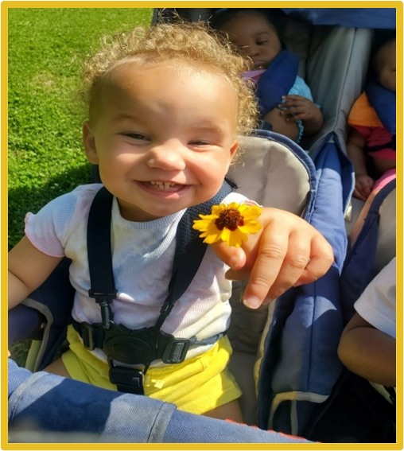

**Program Information Report Data**

(Head Start/Early Head Start)

**HS/EHS**

739/132 # of children funded

904/215 # of children served during the year

44/34 # of classrooms serving children

17/4 # of children in an average class size

**Eligible children/Pregnant women served**

773/208 # of income eligible

460/114 # of public assistance

24/15 # of homeless children served

42/6 # of foster children served

7 # of pregnant women served

**Percentage of Eligible Children Served**

85.5%/96.7%

**Attributes of Families Served**

624/166 # of single-parent families

222/23 # of two-parent families

229/65 # of single-parent families and the parent is not working

21/3 # of two-parent families in which neither parent is working

83/17 # of families without a high school education

423/92 # of families receiving family services

276/38 # father/father figures engaged in all activities during the year

(*Family assessments, family goal setting, involvement in child development,*

*program governance and parenting educational workshops*)

**Volunteers**

22/119 # of volunteers

**Primary language of family at home**

892/213 # of children English primary language

9/0 # of children Spanish primary language

**Health and Disabilities**

 899/208 # of children with ongoing accessible dental care provided

 904/208 # of children with ongoing accessible health care provided

 114/25 # of children with IFSP or IEP

 867/170 # of children complete all for age for immunizations

**Program Information Report Data Continued**

(Head Start/Early Head Start)

**Teaching Staff Qualifications**

36/9 # of teachers with a BS and above in early childhood or equivalent hours

20+/20+ # of hours of teaching staff training and professional development

39/29 # of teachers meeting degree/credential requirement effective September 2013

**PROGRAM EXPENDITURES**

**Head Start/Early Head Start 2023-2024**

|  |  |
| --- | --- |
| Salaries | $6,885,002 |
| Fringe | $2,676,185 |
| Travel | $57,932 |
| Equipment | $46,581 |
| Supplies | $473,909 |
| Contractual | $880,966 |
| Construction | $0 |
| Other costs | $1,292,157 |
| Indirect | $520,963 |
| Training/Technical Assistance | $337,995 |
| Total Expense | *$13,171,690 |

Northwest Tennessee Head Start/Early Head Start is operated by Northwest Tennessee Economic Development Council (NWTEDC). In addition to the grant funds shown above:

$ 666,861 from the U.S. Department of Agriculture (USDA) was the reimbursement for the cost of food used in Head Start.

$ 3,443,327 in non-federal share is required in order to receive the Head Start grant, which is local matching funds from people who donate goods and services (usually rent on the classroom space we use).

In addition, there is private cash and other donations from individuals and businesses throughout the program year. We have received three non-restricted fund donations during program year 2023-2024. These funds are listed below:

|  |  |
| --- | --- |
| Cadence Bank | $5,127.00 |
| TJ Maxx Foundation | $10,000.00 |
| United Way | $851.00 |

Our Head Start/EHS program is held under a CAP Agency, and the funds for the other programs under our agency can be found below:

|  |  |
| --- | --- |
| LIHEAP Infrastructure 23 | $71,067.21 |
| LIHEAP Infrastructure 24 | $64,486.59 |
| LIHEAP 23 | $1,161,080.12 |
| LIHEAP 24 | $2,516,564.42 |
| LIHEAP Supplemental | $1,421,343.46 |
| LIHWAP | $457,845.91 |
| CSBG 23 | $314,063.01 |
| CSBG 24 | $594,546.60 |
| Direct Appropriations | $25,050.00 |
| TEFAP 23 | $32,759.65 |
| TEFAP 24 | $61,000.00 |

**ATTENDANCE**

**2023-2024**

**Attendance Percentage by Center**

**CENTER**   **HS**   **EHS**

|  |  |  |
| --- | --- | --- |
| Benton | --------- | 79.74% |
| Harrelson | 95.19% | ---------- |
| Hollow Rock/Bruceton | 91.76% | ---------- |
| Humboldt | 81.54% | ---------- |
| Huntingdon | 87.24% | ---------- |
| Isaac Lane | 83.30% |  |
| Kenton | 83.78% | ---------- |
| Lake | 82.83% | 87.72% |
| Magic Valley | 83.42% | ---------- |
| McKenzie | 86.57% | 86.01% |
| Milan Elementary Pre-K | 92.94% |  |
| Miles | 81.08% | 70.67% |
| Nova | 88.31% |  |
| Rhea | 91.09% | ---------- |
| Trenton | 89.23% | --------- |
| Troy | 78.53% | --------- |
| Washington Douglas | 76.74% | 74.81% |
| Weakley | 86.30% | --------- |

NORTHWEST TN EARLY HEAD START SCHOOL READINESS GOALS

*Goals are aligned with The Head Start Early Learning Outcomes Framework, The Frog Street Infant and Toddler Curriculum and the Tennessee Early Childhood Early Learning Developmental Standards. Goals are tracked utilizing Frog Street assessment system.

1. **APPROACHES TO LEARNING**

* Children will manage feelings and emotions with the support of familiar adults.

* Children will manage actions and behavior with support of familiar adults.

* Children will maintain focus and sustain attention with support.

* Children will show interest in and curiosity about objects, materials, or events.

* Children will show imagination in play and interactions with others.

2. **SOCIAL – EMOTIONAL DEVELOPMENT**

**\*** Children will develop consistent, positive interactions through secure relationships with familiar adults.

* Children will learn to use adults as a resource to meet needs.

* Children will imitate and engage in play with other children.

* Children will learn to express a range of emotions.

* Children will develop a sense of belonging through relationships with others.

3. **LANGUAGE/LITERACY DEVELOPMENT**

* Children will listen to, understand, and respond to communication and language from others.

* Children will use verbal and non-verbal cues to communicate wants/needs.

* Children will use an increasing number of words in communication and conversation with others.

* Children will handle books and relate them to their stories or information.

* Children will recognize pictures and some symbols, signs, or words.

4. **COGNITION**

* Children will actively explore people and objects to understand self, others, and objects.

* Children will recognize differences between familiar and unfamiliar people, objects, actions, or events.

* Children will use a variety of strategies in solving problems.

* Children will develop a sense of number and quantity.

* Children will observe and imitate sounds, words, gestures, actions, and behaviors.

5. **PERCEPTUAL, MOTOR, and PHYSICAL DEVELOPMENT:**

* Children will demonstrate gross motor manipulative skills.

* Children will demonstrate fine motor manipulative skills.

* Children will use perceptual information to understand objects, experiences, and interactions.

* Children will demonstrate healthy behaviors with increasing independence as part of everyday routines.

* Children will use safe behaviors with support from adults.

**Northwest Tennessee Early Head Start**

**2023-2024**

**AIM Observational Assessment School Readiness Goal Report**

***Percent of students meeting or exceeding age-level expectations at the end of the 2023-2024 school year.***

***Change in percentage of students meeting or exceeding age-level expectations since Fall.***

NORTHWEST TN HEAD START

SCHOOL READINESS GOALS

*Goals are aligned with The Head Start Early Learning Outcomes Framework, The Frog Street Threes and Pre-K Curriculum and the Tennessee Early Childhood Early Learning Developmental Standards. Goals are tracked utilizing the Frog Street assessment system.

1. **APPROACHES TO LEARNING**

* Children will follow classroom rules and routines with increasing independence.

* Children will manage actions, words, and behavior with increasing independence.

* Children will maintain focus and sustain attention with minimal adult support.

* Children will show interest in and curiosity about the world around them.

* Children will express creativity in thinking and communication.

2. **SOCIAL – EMOTIONAL DEVELOPMENT**

**\*** Children will engage in and maintain positive relationships and interactions with adults.

* Children will engage in cooperative play with other children.

* Children will use basic problem-solving skills to resolve conflicts with other children.

* Children will express a broad range of emotions and recognize these emotions in their self and others.

* Children will develop a sense of belonging to family, community, and other groups.

3. **LANGUAGE/LITERACY DEVELOPMENT**

* Children will attend to communication and language from others.

* Children will understand, follow, and use appropriate social and conversational rules.

* Children will understand and use a wide variety of words for a variety of purposes.

* Children will demonstrate awareness that spoken language is composed of smaller segments of sound.

* Children will identify letters of the alphabet and produce correct sounds associated with letters.

* Children will ask and answer questions about a book that was read aloud.

* Children will write for a variety of purposes using increasingly sophisticated marks.

4. **COGNITION**

* Children will know number names and the count sequence.

* Children will understand the relationship between numbers and quantities.

* Children will understand simple patterns.

* Children will measure objects by their various attributes using standard and non-standard measurement.

* Children will identify, describe, compare, and compose shapes.

* Children will engage in scientific talk.

* Children will ask questions, gather information, and make predictions.

5. **PERCEPTUAL, MOTOR, and PHYSICAL DEVELOPMENT:**

* Children will demonstrate gross motor manipulative skills.

* Children will demonstrate fine motor manipulative skills.

* Children will demonstrate personal hygiene and self-care skills.

* Children will develop knowledge and skills that promote nutritious food choices and eating habits.

* Children will demonstrate knowledge of personal safety practices and routines.

**Northwest Tennessee Head Start**

**2023-2024**

**AIM Observational Assessment School Readiness Goal Report**

***Percent of students meeting or exceeding age-level expectations at the end of the 2023-2024 school year.***

***Change in percentage of students meeting or exceeding age-level expectations since Fall.***

**Northwest Tennessee Head Start**

**2023-2024**

**Classroom Assessment Scoring System (CLASS) Chart**

**2023-2024 Department Of Human Services License**

During the 2023-2024 program year, the Department of Human Service used an assessment tool, the Quality Rating Improvement System (QRIS). The QRIS is designed to score two (2) different areas of quality on a quarterly basis for a total of four (4) visits. These two (2) broad quality components are: Health and Safety and Teacher-Child Interactions. The total score possible for each visit is 100. Upon completion of the fourth visit the four (4) scores are averaged to determine the overall score for the child care agency. All centers received the highest rating in the Item/Element Categories of choice.

**Northwest Tennessee Head Start**

**2023-2024**

**Education Coaching Data**

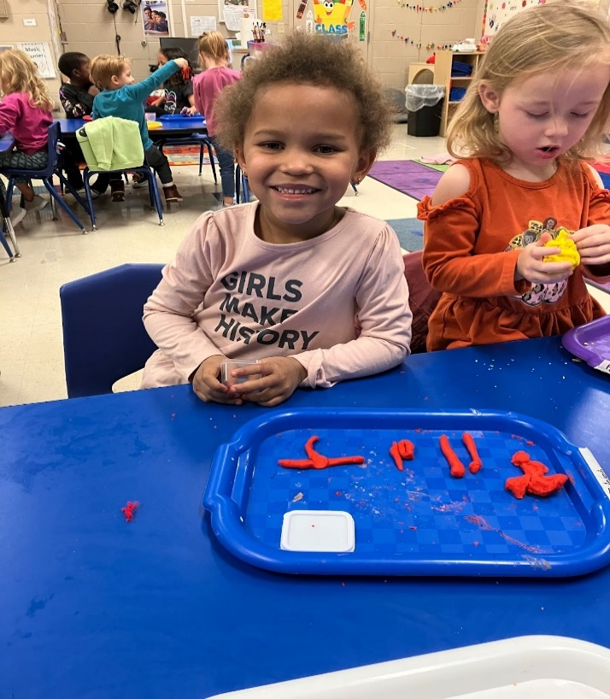 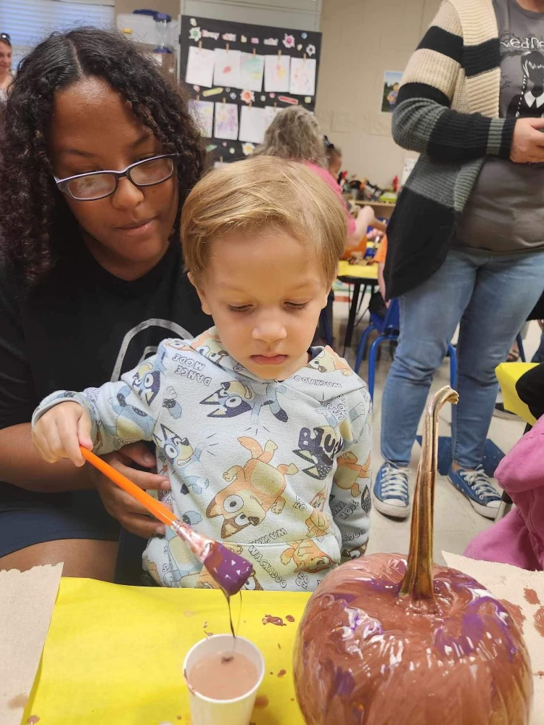

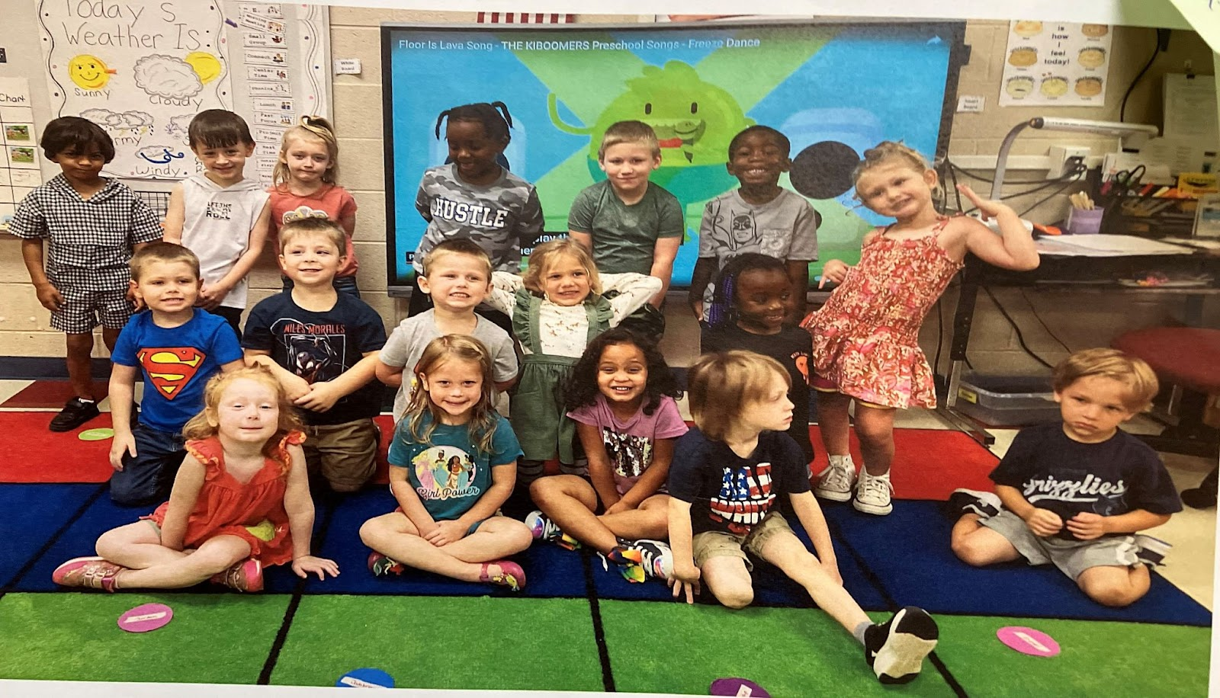

This year 373 of our children transitioned to kindergarten. To help make transitioning a success for our children from Head Start to kindergarten we prepared them by introducing them to kindergarten routines. A tour of where they will attend kindergarten is provided where possible. The children are registered for kindergarten prior to leaving Head Start.

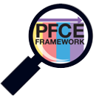**PFCE Framework**

**Northwest TN Head Start/Early Head Start**

**Family & Parent Engagement Outcome Goals**

* Family Well-Being: Parents & Families are safe, healthy, and have increased financial security.
* Positive Parent/Child Relationships: Beginning with transitions to parenthood, parents and families develop warm relationships that nurture their child’s learning and development.
* Families as Lifelong Educators: Parents/Families are strong advocates and participants in the everyday learning of their children.
* Families as Learners: Families and parents observe, guide, promote and participate in the everyday learning of their children at home, school and in their communities.
* Family Engagement in Transitions: Parents and families support and advocate for their child’s learning and development as they transition to new learning environments, including EHS to HS, EHS/HS to other learning environments, and HS to Kindergarten through elementary school.
* Family Connections to Peers & Community: Parents and families form connections with peers and mentors in formal or informal social networks that are supportive, educational, and enhance social well-being and community life.

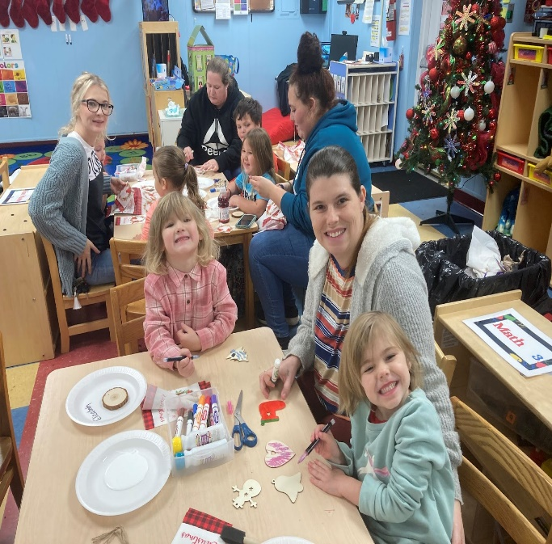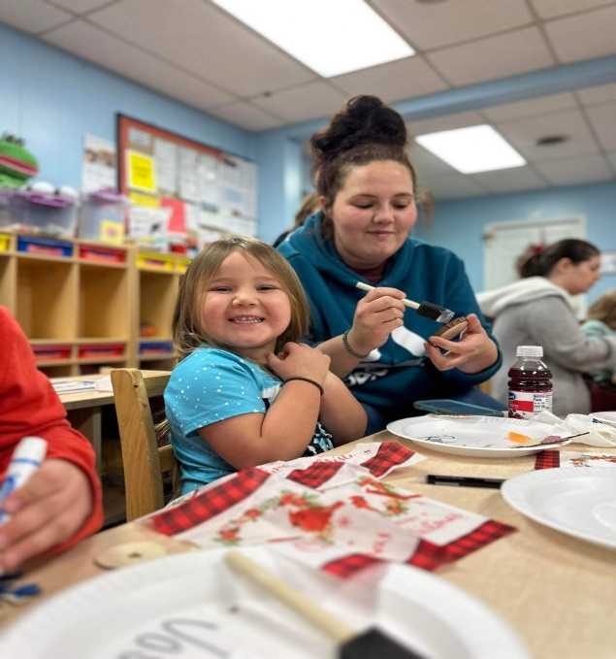

**Family Outcomes – Early Head Start**

**Fall 2023-Spring 2024**

|  |  |  |  |
| --- | --- | --- | --- |
| **Family Outcome** | **Preliminary Average Score** | **End of Year Average Score** | **Gain/Loss** |
| Safety | 2.2 | 2.2 | 0 |
| Housing | 2.2 | 2.3 | 0.1 |
| Health | 2.4 | 2.5 | 0.2 |
| Mental Health/Substance Abuse | 2.2 | 2.3 | 0.1 |
| Transportation | 2.3 | 2.3 | 0.1 |
| Financial Security | 2.2 | 2.3 | 0.1 |
| Nurturing Relationships | 2.2 | 2.4 | 0.2 |
| Child Development/Parenting Skills | 2.1 | 2.3 | 0.2 |
| Family Education at Home | 2.0 | 2.3 | 0.2 |
| School Readiness | 2.0 | 2.3 | 0.3 |
| Promoting Primary Language | 2.7 | 2.9 | 0.2 |
| Education, Training, and Life Goals | 2.0 | 2.1 | 0.1 |
| Volunteering | 1.7 | 1.8 | 0.2 |
| Transitions | 2.0 | 2.2 | 0.2 |
| Families and Communities | 2.0 | 2.1 | 0.1 |
| Leadership and Advocacy | 1.8 | 1.9 | 0.1 |
| **Total** | **34.1** | **36.3** | **2.3** |

Early Head Start families showed an increase of 2.3 points overall in family outcomes.

**The largest gains were in the areas of:**

* School Readiness

**Family Outcomes - Head Start**

**Fall 2023-Spring 2024**

|  |  |  |  |
| --- | --- | --- | --- |
| **Family Outcome** | **Preliminary Average Score** | **End of Year Average Score** | **Gain/Loss** |
| Safety | 2.3 | 2.5 | 0.2 |
| Housing | 2.3 | 2.5 | 0.2 |
| Health | 2.6 | 2.8 | 0.2 |
| Mental Health/Substance Abuse | 2.2 | 2.4 | 0.2 |
| Transportation | 2.4 | 2.6 | 0.2 |
| Financial Security | 2.4 | 2.5 | 0.1 |
| Nurturing Relationships | 2.3 | 2.5 | 0.2 |
| Child Development/Parenting Skills | 2.3 | 2.5 | 0.3 |
| Family Education at Home | 2.2 | 2.5 | 0.3 |
| School Readiness | 2.1 | 2.4 | 0.3 |
| Promoting Primary Language | 2.9 | 2.9 | 0.1 |
| Education, Training, and Life Goals | 2.0 | 2.2 | 0.2 |
| Volunteering | 1.3 | 1.6 | 0.3 |
| Transitions | 2.0 | 2.4 | 0.3 |
| Families and Communities | 2.0 | 2.1 | 0.2 |
| Leadership and Advocacy | 1.5 | 1.7 | 0.2 |
| **Total** | **34.9** | **38.1** | **3.3** |

Head Start families showed an increase of 3.3 points overall in family outcomes.

**The largest gains were in the areas of:**

* School Readiness
* Transitions
* Volunteering
* Child Development/Parenting Skills
* Family Education at Home

**Health, Mental Health, Disabilities and Nutrition Services**

The Northwest Tennessee Head Start/Early Head Start Program recognizes that healthier children are ready to learn. The program supports children’s learning and wellness through comprehensive health screenings which include: a physical exam/well child exam, dental exam, lead, hearing, vision, speech, developmental, behavior, and growth assessment.

The program collaborates with four mental health facilities: Practical Behavior Analysis, Pathways Behavioral Health, Positive Living Group and Camelot Care to provide observations and strategies that support classroom activities and individual behavior. The program also partners with TN Voices who provide observations, strategies and activities to improve classroom management skills.

Disability services for Head Start children are provided through the local education agencies over the eight-county area that we serve. Infants and toddlers in the Early Head Start Program are provided services through Tennessee Early Intervention Services (TEIS).

The children enjoy meals and snacks that are culturally and developmentally appropriate and meet the nutritional needs of each child. Our program complies with the USDA guidelines.





* 900 children had health insurance
* 904 children had a medical home
* 899 children had a dental home
* 712 children were up to date on age-appropriate preventative and primary health care
* 867 children were complete all for age on immunizations
* 728 children completed professional dental examinations

**78.76% of enrolled Head Start Children received medical exams & 80.53% of enrolled Head Start children received dental exams.**

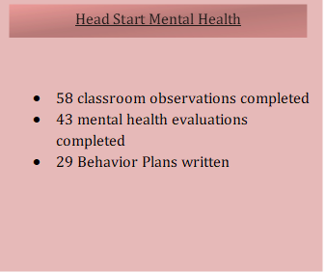



* 114 children with IEP
* 54 children with IEP developed prior to the program year
* 60 children with IEP developed during the program year

Primary Disabilities

77 Speech Impairments

7 Autism

25 Developmental Delay

1 Hearing Impairment

1 Health Impairment

1 Intellectual Disability

1 Traumatic Brain Injury

1 Orthopedic Impairment



* 206 children had health insurance
* 208 children had medical home
* 208 children had dental home
* 133 children were up to date on age-appropriate preventative and primary health care
* 170 children were complete all for age on immunizations
* 162 children received a professional oral exam

**61.86% of enrolled Early Head Start children received medical exams & 75.35% of enrolled Early Head Start children received dental exams.**



* 7 pregnant women
* Services provided:

-Newborn Visits

- Dental Exams

- Prenatal and Postpartum Care

- Prenatal and Postpartum Information

- Nutrition

- Substance Abuse and Prevention and

Treatment

* Fetal Development
* Safe Sleep Practices
* 8 pregnant women with at least one type of health insurance:
* 7 Medicaid
* 0 Private Insurance
* Pregnancy Age

-2 Adolescent (10 - 16 years of age)

* 2 Teen Moms (17 - 19 years of age)
* 3 Adults Moms (20 – 35 years of age)
* Prenatal Medical Services
* 1 Enrolled First Trimester
* 3 Enrolled Second Trimester
* 3 Enrolled Third Trimester



* 25 children with IFSP
* 14 children with IFSP developed prior to the program year
* 11 children with IFSP developed during the program year

**2023 - 2024 HEALTH SERVICE DATA**

**(Based on Cumulative Enrollment)**

**Federal Review and Audit**

In the most recent financial audit, there were no findings.

All our documents are available for public review at the grantee office, Northwest Tennessee Economic Development Council located at 231 South Wilson Street, Dresden, Tennessee 38225. Contact can also be made at (731)364-4831.

